Outcome harvesting workshop
March 2022
Welcome to a new opportunity to participate in online training for organisations/partners receiving grants through the Danish Disability Fund.
In 2021 the reporting formats used for the Danish Disability Fund were revised and are now based on the outcome harvesting approach for identifying, formulating and analyzing outcomes, and an approach which cuts away the fluff and focusses on what is key.
This workshop provides an opportunity for both beginners and those with some experience to become (more) familiar and confident with the method. During the workshop you will develop and refine a number of outcome statements for your own project, which can be used directly in your (annual) reporting to DPOD – thus allowing you to combine reporting and learning in one go .

Target group: Two participants from each South partner /country office to participate along with the relevant staff member or volunteer(s) from the Danish partner. Participants should be those involved in the day to day managing of the HP grants – ie. those who are most familiar with the project and its results.

Requirements: All participants must have access to a computer, good internet connection and be able to follow the presentations and write outcomes in English.

When and where: Online workshop, spread over one working week – 3 hours daily from 8.00 – 11.00 am UTC (Universal Time Corrected). The Outcome harvesting workshop will be run twice to allow wide participation across the Disability Fund.

The Thursday before each workshop starts there will be a kick-off session, where you will get the opportunity to ‘meet’ the other participants and become familiar with the online tools which will be used during the workshop.

For those who are interested there is an additional optional Q&A session on Monday 14 March (after the two outcome harvesting workshops have been completed) focusing on the second part of the results sheet, ‘Targets groups reached’. This session is not related to the outcome harvesting workshop – but is related to the annual and final reporting formats. See overview of dates below.

 | Option 1 (week 9) | Option 2 (week 10)
Kick-off session  (30-60 min.) | 24th of February, 2022  9.00 am (UTC) | 3rd of March, 2022  9.00 am (UTC)
Workshop | 28th of February – 4th of March  8.00 – 11.00 am (UTC) | 7th – 11th of March  8.00 – 11.00 am (UTC)
Extra optional Q&A session on ‘Target group reached’ | Monday 14th of March 9.00 UTC

Programme: The workshop will be based on a variation of presentations, small exercises, discussion, hands on and feed-back. See attached programme.
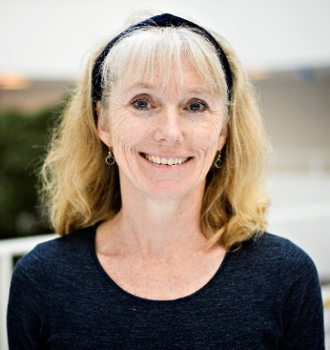
Register for the event: First step is to agree on the participation with your Danish partner. Later we will send you a registration link to register yourself with your contact details.
Facilitators: Lead facilitator of the workshop is Richard Smith, Consultant and outcome harvesting specialist. Co-faciliator is Gitte Robinson, Senior MEL Advisor in DPOD.

Time zones: See table below for the different timezones indicating when the workshop sessions start in your timezone (notice that the kick-off session, and Q&A session both start an hour later).
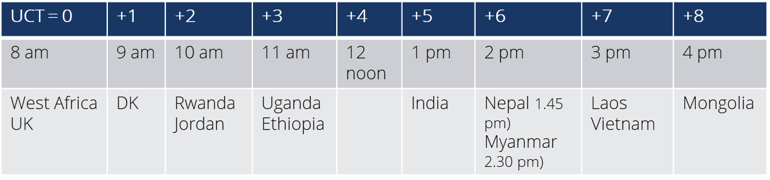

In some cases of bigger Danish organisations or South partners with several projects funded through the Danish Disability Fund it may be possible to add one or two additional participants.
The last day of the workshop is a little shorter, and thus runs from 8.00-10.30 am (UTC).

