REQUIREMENTS - PROGRAMME BUDGET
Indhold
1. GENERAL REQUIREMENTS 2
2. COST CATEGORIES 3
2.1. The cost category relevant for local implementing partners 3
2.2. The cost categories relevant for the Danish applicant / grant holder 4
• A1 and A3: Activity cost vs. Support cost 4
• A3 and B1: Different types of support costs 4
• A5: Information work in Denmark 4
• A6: Unallocated funds 4
• A7: Audit in Denmark 5
• B1: Administration in Denmark 5
• B2: Disability compensation in Denmark 5
2.3. Fair and transparent cost allocation mechanism 5
3. PROGRAMME BUDGET FORMAT 8
3.1. TAB 1A. Budget resumé 8
Disability Programme Funds 8
Disability Fund Budget – Outcome Based 8
Disability Fund Budget – Cost Categories Specification 9
Disability Fund Budget – Geographic Specification 10
3.2. TAB 1B. Detailed budget 10
3.3. TAB 1C. Budget notes 12
3.4. TAB 1D. Danish workhours 12
3.5. TAB 1E. Self-funding 13

GENERAL REQUIREMENTS
This guide sets out the requirements regarding how to present the program budget. Please note that requirements for managing the budget during the implementation of the programme are found in the Danish “Håndbog for projekt og økonomistyring”, including the annex “særlige forvaltningskrav af programmer” which can be found at DPODs website.

The general requirements follows the Danish “Håndbog for projekt og økonomistyring” as for insurance, travel expenses, etc.
The budget should be prepared according to the corresponding Programme Budget Format and must be presented in a clear and transparent manner. It is important for the assessment of the programme application that the budget is easy to understand.
Extra requirements are as follows:
- Yearly budget: A programme budget normally covers four years but a yearly budget must be developed and presented to DPOD 1st of March each years.
- Mid-term review: In the third year of the program period, the organization is obliged to carry out a mid-term review of the programme. The mid-term review can be either internal or external, and the cost is expected to be appropriate with the size of the programme. It is possible to cover the fees of an external consultant and the external consultant’s travel expenses, accommodation, per diem and milage allowance when following the conditions specified in the above section on ‘Travel Expenses’.
- By the end of the programme period DPOD will carry out a review of the programme. The cost of the review will be covered by DPOD but programme organisations must set budget aside e.g. for manhours to participate in meetings in Denmark as part of the review. If organisations wants to participate in the review visit in partner countries (two countries will receive a physical visit), this should also be included in the programme budget.

COST CATEGORIES
The program budget, like the other budget formats in the Danish Disability Fund, includes cost categories to create a more transparent funding model. This allows tracking of which costs are incurred by partners and which costs are in Denmark, as well as distinguishing between direct and indirect costs.
The cost categories are automatically distributed and calculated in a special "Summary" section on the first sheet of the program budget.
Cost categories:
- A1: Activity costs directly linked to the implementation of programme activities
- A2: Implementation through local partners / Transfers to Global South
- A3: Support costs necessary to support programme management
- A4: Not relevant
- A5: Information work in Denmark
- A6: Unallocated funds
- A7: Audit in Denmark
- B1: Administration in Denmark
- B2: Disability compensation in Denmark

In short, transfers to the South are recorded as A2 costs, while the remaining costs are categorized under the North.

For this reason, this chapter will elaborate on the meaning of the different cost categories.

The cost category relevant for local implementing partners
All costs in the budget for and managed by local independent implementing partners fall into the cost category A2.

In the detailed budget, A2 is divided into four sub-categories to make the proportionality between different types of partner costs more transparent.

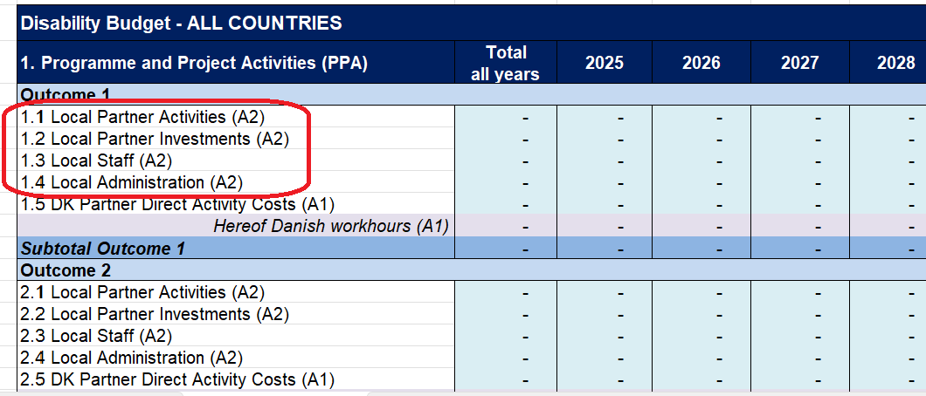
The sub-categories are:
- Local Partner Activities
- Local Partner Investments
- Local Staff
- Local Administration

The cost categories relevant for the Danish applicant / grant holder
Except for A2, all other cost categories are relevant for the Danish applicant/grant holder only. Please note that country and regional offices, that are functioning as extensions of the programme organisation are seen as part of the Danish applicant.

A1 and A3: Activity cost vs. Support cost
Examples:
A1: A project manager’s salary for the time spent on programme activities that are directly linked and allocated to outcomes. Activities could be e.g., management of an activity, technical assistance, capacity development and monitoring.
A3: An accountant’s salary for the time spent on supporting programme implementation e.g., paying bills, bookkeeping etc.
The cost categories A1 and A3 cover management costs by the Danish applicant / grant holder and it is costs that are necessary to deliver a programme.

However, A1 and A3 differs with respect to their purpose where:
  - A1 is activity costs directly linked to the implementation of programme activities.
  - A3 is support costs necessary
to support programme management.

A3 and B1: Different types of support costs
Please note:
Support cost that are not directly necessary to deliver a programme is B1 costs (see below). The audit of the organisation’s annual accounts and other costs related to the administration and accounting of the organisation itself, fundraising as well as visits and monitoring visits not part of activity-specific monitoring are example of B1 cost.
The cost categories A3 and B1 are both support costs related to management by the Danish applicant/grant holder.
However, B1 and A3 differs with respect to what they support, where:
  - A3: are support cost related directly to the implementation of the programme.
  - B1: are support cost not related directly to the implementation of the programme but rather the Danish applicant/grant holder’s organisation in general.

A5: Information work in Denmark
The cost category A5 covers support for information work in Denmark directly related to the programme. The maximum annual budget of this cost category is 2 % of the ‘Total PPA’, but the amount can be accumulated over the programme period.

A6: Unallocated funds
The cost category A6 covers the costs that are unspecified at the time of budgeting i.e., the sums of what was former known as 'budget margin'. Unallocated funds should be used to: Seize new opportunities, to react to new situations, to respond to acute demands or challenges within the programme, or to cover unforeseen expenses like currency fluctuations raising the costs of the intervention. Both the Danish grant holder and the local partner(s) should be involved in deciding the utilization of these funds.

The maximum annual budget of this cost category is 15% of PPA i.e., the sum of the cost categories A1, A2 and A3.

The spending of unallocated funds must always be in pursuit of the programme’s overall objective, and they may be used without prior approval from DH for activities that clearly supplement or innovate the programme activities. You may transfer funds from this budget line to one or several of the other main budget items if the need arises.

A7: Audit in Denmark
The cost category A7 covers auditing in Denmark and at possible field offices of the programme accounts. Please note, that it is only auditing of the programme accounts that is included in this cost category:
  - Costs for auditing of local partner's annual programme accounts must be budgeted under the ‘Local Administration (A2).
  - Costs relating to the auditing of the Danish grant holder organisation's annual accounts should be covered by the ‘Administration in Denmark (B1).

B1: Administration in Denmark
The cost category B1 covers the administration in Denmark. The administration fee should cover the Danish applicant’s general additional administrative costs in connection with the approved intervention, when these do not pertain to any of the other budget items.

Up to 7% of the sum of ‘4. Total Costs’ and ‘Disability Compensation’ may be set aside in the budget for administration in Denmark.

B2: Disability compensation in Denmark
Disability compensation describes costs associated with disability, e.g. bringing along a personal helper, sign language interpreter, special transportation and other aids needed for active participation in the implementation of a programme or intervention.

Note: Only costs related to Danish employees/volunteers can be included here. Any local disability compensation must be included as activity costs. Amounts budgeted in this line are excluded from the program assessment criteria and cannot be used for any other purpose.

Fair and transparent cost allocation mechanism
The allocation of costs through a fair and transparent cost allocation mechanism is relevant for both the local partner’s budget as well as the applicant/grant holder’s budget.

A cost allocation mechanism is applied when a cost is not only related to the programme. Typically, this applies for organisational costs/core costs such as rent, salaries for accountants, office supplies and the likes.

If this is the case, it is required that a cost allocation mechanism is used to calculate how much of the cost should be covered by the programme budget. You may apply the cost allocation mechanism that you prefer, but it is important that the cost allocation mechanism is fair and transparent (see examples below).

The cost allocation can be based on e.g., time registration, number of employees (pro rata), project portfolio of the organisation. It is important that the cost allocation mechanism up front is based on data available at the time of budgeting, but that the cost allocation mechanism is realised on actual costs at the time of the accounts. The auditor checks this as part of the yearly programme audit.

This also means that the ‘fair share’ calculation is not static, as the basis for the calculation can alter during the programme period (e.g., the project portfolio can change, the amount of employees may change, the size of the organisational core cost may change). Therefore, it can be necessary to modify the fair share calculations used when relevant during the programme period.

The allocation mechanism should be described under the relevant budget line in the tab ‘1C. Budget notes’.
Example 1:
An A1 cost need to be allocated among more than one outcome. This could be the project manager’s travel cost for a visit to 2 different partners in different countries.
The project manager’s time spend:
- 5 days of her 7 traveling days in country A where she works equally with outcome 1 and 2.
- 2 days of her 7 traveling days in country B where she works only with outcome 2.

Cost allocation mechanisms could be:
- Outcome 1, country A: 5/7 * 0,5 = 0,71 * 0,5 = 0,36
- Outcome 2, country A: 5/7 * 0,5 = 0,71 * 0,5 = 0,36
- Outcome 2, country B: 2/7 = 0,28

Example 2:
An A3 cost need to be allocated among the programme and the grant holder’s other projects. This could be office costs including rent, cleaning, utilities and supplies, telephone and internet costs, goods, materials, maintenance etc.

Cost allocation mechanisms could e.g., be:
- Based on ‘head counts’: 2 of the 3 employees works on the programme i.e., 2/3 = 67 % of the cost is allocated to the programme.
- Bases on project portfolio: The organization has a project portfolio of DKK 6 million, if the programme is granted. The programme budget is DKK 4 million i.e., 2/3 of the project portfolio comes from the programme
= 67% of the costs is allocated to the programme.
- Based on time registration-key (i.e., hours): 2.892 work hours of in all 4.520 work hours have been spent on the programme i.e., 2.892/4.520 = 64 % of the costs is allocated to the programme.

Please note that the three allocation mechanisms in example 2 all are considered fair as they all allocate a rather similar percentage of the cost to the programme (67 % and 64 % respectively). If an allocation mechanism results in an unfair allocation, it cannot be applied.

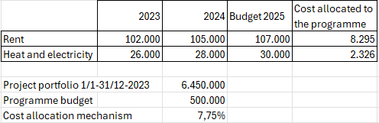
Examples 3:
In this picture you find an example of how to calculate ‘fair share’. The cost allocation mechanism employed is based on the size of the project portfolio in relation to the programme budget. This allocation mechanism is then used on the amounts budgeted for in 2023, which provides you with the amount that the programme budget can cover.

PROGRAMME BUDGET FORMAT
The spreadsheet ‘Programme Budget Format’ consists of the following tabs (in Danish: ‘faneblade’):
- 1A. Resumé.
- 1B. Detailed budget
- 1C. Budget notes
- 1D. Danish workhours
- 1E. Own financing
There are cells that are automatically calculated in all the tabs. These cells are either blue, grey or purple.
Please be aware only to write in white cells.

TAB 1A. Budget resumé
Insert the name of the applicant (i.e., organisation’s name) and the programme title as indicated.

Disability Programme Funds
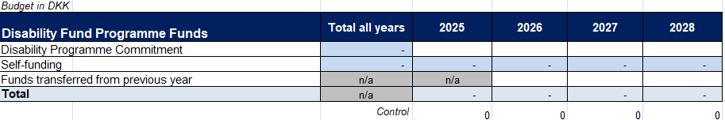
The first part of the Tab 1A. Resumé contains the Disability Programme Funds:
This table is used to keep track on the total budget amount for each year of the programme. Under the line ‘Disability Programme Commitment’, the amount granted per year is inserted. Under the line ‘Funds transferred from previous year’, unused funds to be transferred to the coming year (max 15 %) can be inserted. The total budget amount is automatically calculated. The ‘Total’ should be equivalent to ‘5. Grand Total’ in the next table, and if this is not the case, it will be evident in the control cells.

Disability Fund Budget – Outcome Based
Outcomes need to be specified in the application and, hence, also in the budget. This specification is done in the table ‘Disability Fund Budget - Outcome Based’.

Please do not write in any of the cells, as the information is transferred from tab 1B. Detailed budget.

In section ‘I. Programme and Project Activities (PPA)’, insert outcomes as indicated.

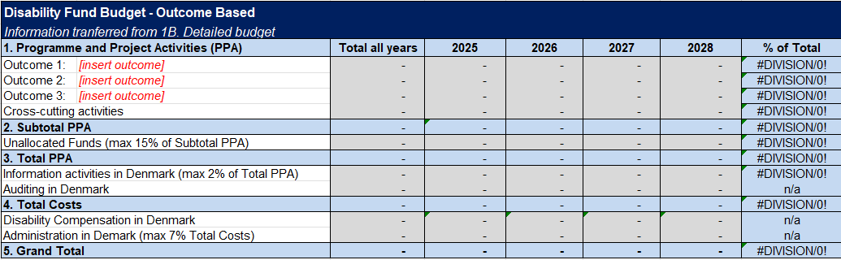
The total costs of all outcomes (incl. Cross-cutting activities); 2. Subtotal PPA is automatically calculated, and so is 3. Total PPA, 4. Total Costs, and 5. Grand Total.
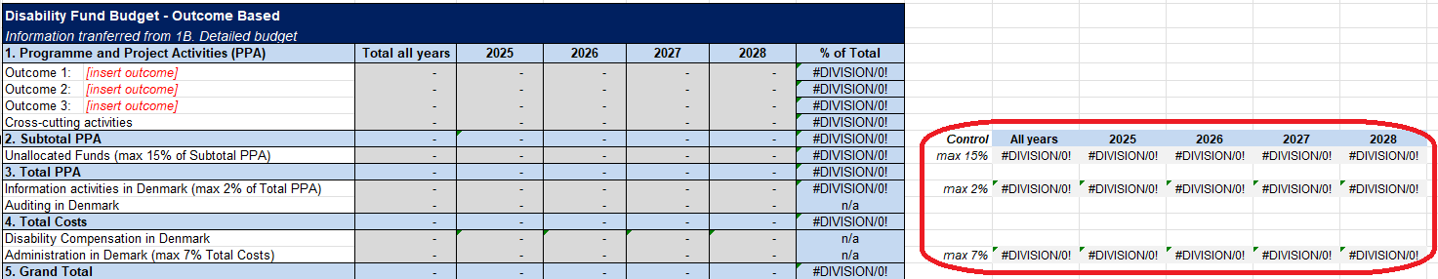
Please check that neither ‘Unallocated Funds’, ‘Information activities in Denmark’, and ‘Administration in Denmark’ exceeds the maximum percentages allowed. The percentages are automatically checked in the control table cf. the blue cells in rows 23, 25, and 29 columns K to O (see furthest right):

Disability Fund Budget – Cost Categories Specification
The next table contains a breakdown of each cost category per year and for all years. It also shows the % of each cost category in relation to ‘5. Grand Total’.

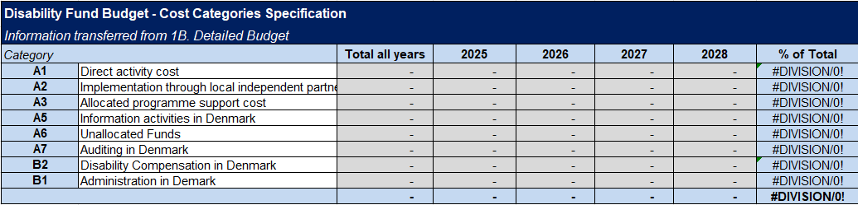
The information is transferred from ‘1B. Detailed budget’, and therefore, please do not write in any of the cells.

Disability Fund Budget – Geographic Specification
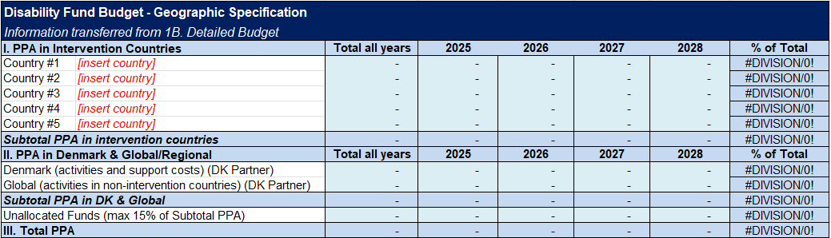
The last part of Tab ‘1A. Resumé’ contains the geographical breakdown of the Programme and Project Activities (PPA). Please only insert countries as indicated, the remaining information is transferred from ‘1B. Detailed budget’.
Under ‘II. PPA in Denmark & Global/Regional’:
- ‘Denmark (DK Partner)’ refers to costs managed by the Danish grant holder for
  - Activities in Denmark (if any) and
  - All support costs (A3) e.g., fair share of office costs and salary for support functions.
- ‘Global & Regional (DK Partner)’ refers to costs managed by the Danish grant holder for activities in non-intervention countries and not in Denmark (e.g., participation in international events).

TAB 1B. Detailed budget
Insert the name of the applicant (i.e., organisation name) and the programme title as indicated.

The detailed budget is structured around the respective intervention countries to achieve an overview of the budgeted costs for each country.

Disability Fund Budget – ALL COUNTRIES
Please note that the PPA costs in this table automatically refers to the country tables, and therefore, you should not write in any of the blue, gray, or purple cells.

Only Unallocated Funds, Information activities in Denmark, Auditing in Denmark, Disability Compensation and Administration in Denmark need to be filled out in this table. Be aware of the maximum ceilings for these budget lines (as described under 5.1).
The box Unspent funds to be transferred to next year can be filled in in connection with a budget modification or the yearly audits, and the amount here should be inserted in the corresponding table ‘Funds transferred from previous year’ in tab 1A. Budget resumé.

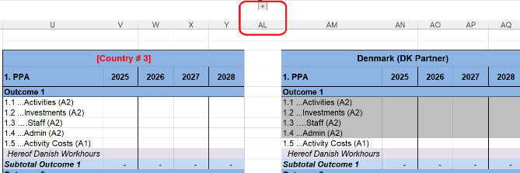
Country tables
Please specify the countries of intervention as indicated in each of the blue tables. If there are more than three intervention countries, two more country tables will be visible by pressing the +/-sign over column “AL”.

Each country budget is structured according to the programme outcomes (incl. cross-cutting activities). Under each outcome, there are five budget lines, being:
Please do not add rows as all costs should be placed under the given budget lines.
Each budget line must be filled in per year of the programme, using the correct programme.
- Local Partner Activities (A2)
- Local Investments (A2)
- Local Staff (A2)
- Local Administration (A2)
- DK Partner Activity Costs (A1)
Hereof Danish workhours
Under the outcome for “Cross-cutting activities” a sixth budget line is added to the above mentioned budget lines, being: “1.6. DK Partner Support Costs (A3)” and “Hereof Danish workhours”.
This means that DK Partner Support Costs (A3) should only be placed under ‘Cross-cutting activities’, and that:
- IF the Danish applicant has country and regional offices, that are functioning as extensions of the applicant organisation, support costs shall be budgeted under the specific country table.
- IF the Danish applicant only has an office in Denmark, ALL DK Partner Support Costs should be placed under the table “Denmark (DK Partner)

The last two tables (furthest to the right) are for costs managed by the Danish applicant. These being the tables:
- Denmark (DK partner) for programme activities in Denmark, e.g., partnerships meetings in Denmark, and for support costs.
- Global (DK partner) for programme activities in non-intervention countries e.g., international conferences
Please do not include costs managed by partners, as these A2 costs should be placed under the respective country of which the partner(s) reside (hence, the cells are grey).
How to place costs for and managed by the Danish applicant organisation:
DK Partner Direct Activity Costs: Workhours, travel costs etc. is placed under the relevant country, where the activity is to take place. Workhours also include time for preparation and finalization, meaning that it is not only hours spent in the given country that should be budgeted in the country tables. If the activity concerns more than one country, the cost is split between the relevant country tables. If the activity is to take place in Denmark, the cost is placed in the table “Denmark” and “Global” if the activity is neither in Denmark nor any of the intervention countries.

DK Partner Support Costs: Workhours, fair share of organizational core costs etc. is placed under the table “Denmark” – unless the Danish applicant organisation has country or regional offices outside Denmark.

TAB 1C. Budget notes
The tab 1C. Budget notes should be used to unfold the costs under each outcome for the sake of enhancing the understanding of the budget and the coherence with the narrative parts of the application.

It is not necessary to describe each budget line in detail, but instead describe cluster of activities, types of investments, human resources needed and the likes. When describing these, please make referral to the relevant intervention country and section in the application. If necessary, more rows can be added.

The budget notes should also be used to explain the allocation mechanism behind the fair share calculations used.

TAB 1D. Danish workhours
The tab ‘1D. Danish workhours’ functions as budget notes for the workhours budgeted for under each country. The tab must be filled out if the budget covers salaries or fees for permanent employees, temporary employees, or volunteers in the Danish organisation. It is a good idea to include expected wage rises during the intervention period.

If you expect to have Danish workhours, this needs to be specified:
- Per outcome for cost categories A1 and for cross-cutting activities for A1 and A3.
- For Information activities in Denmark.

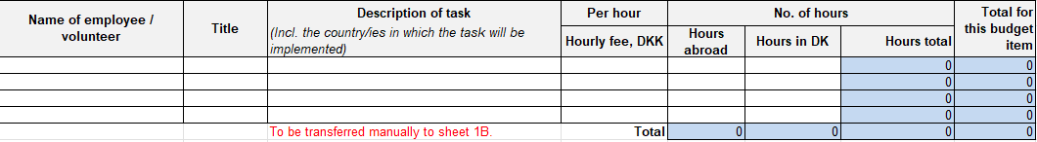
The specification is made in tables like the one below:
Specify the following in the white cells, thus declaring what each person will contribute, how and to what end:
- Name of employee/volunteer.
- Title.
- Description of task (including the country/ies in which the task is implemented)
- Hourly fee, DKK.
- Hours abroad.
- Hours in Denmark.

It is not possible to establish an exact ceiling for the proportion of a grant that may be spent on Danish workhours. However, the Danish workhours will be assessed paying attention to the following aspects:
- The need for Danish labour should be justified by the needs of the local partner or target group.
- There must be reasons not to hire local people to carry out the task.
- The Danish input funded by the grant should not give rise to dependency on the Danish partner.

For the purposes of strengthening the partnership, it is possible to budget for the visits required to this end, either in combination with programme monitoring or, to a reasonable extent, as activities in their own right.

There is no distinction in principle between the person-hours of permanent, temporary, and voluntary personnel dedicated to the implementation of a grant. In all cases, the rates must adhere to the rules specified in section “3. General requirements”.

TAB 1E. Self-funding
Self-funding is to be specified in the tab 1E. Fill in the white cells for each of the programme years.

In the DPOD Programme Guidelines on p. 14, you can read more about the minimum requirements to self-financing, which depends on the total size of the programme’s budget.

When in doubt on how to categorize an own financing input, please consult with DPOD.

https://handicap.dk/internationalt-samarbejde/inspiration-til-projektarbejdet/program-handicappuljen
Direct costs are the costs of all necessary and reasonable inputs associated with functions, which are directly necessary to deliver a programme or project
Indirect costs are the costs of all necessary and reasonable inputs associated with functions, which are directly necessary to manage the agency as a whole, provide oversight over all its activities and put into place the overarching policies, frameworks and systems that enable it to operate.
‘Independent’ in relation to implementing partner is to be analysed and justified in terms of the following indicative criteria: Judicial independence, independent governance structure, degree to which it is rooted in local community (e.g., through volunteers, membership base, local donation). Hence, A2 costs do not include transfers to country and regional offices of the programme organisation nor to the international alliances, to which the programme organisation is a member

