APPLICATION

B1: SMALL-SCALE DEVELOPMENT PROJECT

Maximum amount: DKK 500,000

Cover page

This is an application for: | ☐ Small-scale development project  ☐ Partnership intervention
Danish applicant organisation (financially responsible):
Contact person for the project: | Name:  Email address:  Telephone number:
Additional Danish partner organisations(s):

Partner organisation(s) in country(-ies) of cooperation:

Title:

Country(-ies) of cooperation:

Time period: | Start date:  Click here to insert a date | Completion date:  Click here to insert a date | Total number of months:
Amount applied for: | Total amount:  DKK | Of which disability compensation:  DKK
Signature of applicant organisation’s legally authorised representative:  The signature attests to the Danish organisation’s commitment to the proposed partnership and to this application for a small-scale project and confirms that it is in conformity with the Disability Fund’s guidelines. It also confirms that the signatory legally represents the Danish organisation. | Click here to insert a date.  Date Signature of legally authorised representative  Place Name of representative (block letters)
Does this cooperation involve a new partner organisation? | ☐ Yes  ☐ No  Indicate the six-digit case number (Danish “HP-nr.”), if the cooperation has previously been supported by the Disability Fund:
Is this a re-submission? (I.e. a revised version of a previously submitted application) | ☐ No  ☐ Yes  If yes, indicate reference number of previously submitted application:
Would you prefer the assessment of your application in: | ☐ Danish  ☐ English
Have you received advice from DPOD in relation to this application? | ☐ Yes  ☐ No

Which of the Sustainable Development Goals are mainly being addressed in this project?

[Tick 2-3 of the boxes below indicating the goals primarily addressed.]
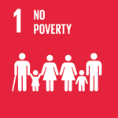☐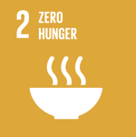☐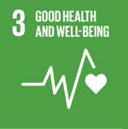☐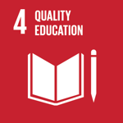☐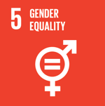☐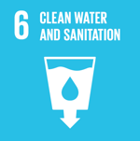☐

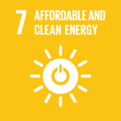☐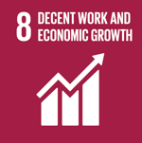☐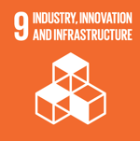☐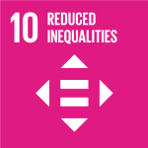☐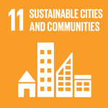☐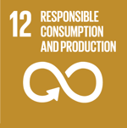 ☐

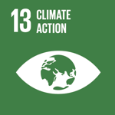☐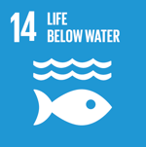☐ 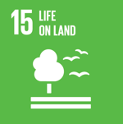☐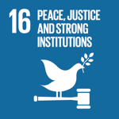 ☐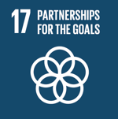 ☐

Synthesis
(Brief description of the intervention in Danish, max. 200 words. This will be used as a presentation of the project on DPOD’s website.)

Guide

The application is composed of the following parts:

Cover page

Key information about the applicant(s) and intervention to be funded, as well as the signature of the Danish applicant organisation’s legal representative.

Part I Application text. This must describe:

● Context and problem analysis

● Prior experience which the application is based on

● The strategy and expected change

The application text should be written with sufficient detail to be understood by an outsider without prior knowledge of the context, project or applicant.

All text on grey background is intended as a guide and should be deleted before the application is submitted.

TIP: You can easily delete all the text on grey background in one go – open ‘home’ (startside) and find styles (typografier) – right click on the style “Heading 5” (overskrift 5) press ‘select all’ (‘vælg alle forekomster’). Now press delete on your keyboard.

Part II List of annexes: Here we ask you to itemise obligatory and supplementary annexes substantiating the application.

Part III Checklist: This last part consists of a checklist to be crossed off before submission, to make sure the application is not rejected on administrative grounds.

Please also note that: the application should be developed in cooperation between the Danish applicant organisation and its partner(s). All applications must therefore be prepared in a language that is shared by the Danish organisation and its partner(s), and subsequently submitted in either Danish or English.

Advice and assistance: The Guidelines for the Disability Fund, which are available at handicap.dk/internationalt-samarbejde, provide tips on the application process, how to develop a good project, and explanation of the conditions and requirements which apply to each type of application. Moreover, DPOD’s advisors are always ready to assist. They can be reached by email at: ais@handicap.dk.

Submission of application:

The application including checklist and obligatory annexes should be submitted to: ansogning@handicap.dk

Applications can be submitted at any time

I. Application text (max length: 10 pages)
The application text must not exceed 10 pages (arial size 11, line spacing 1,0, margins: top 3 cm, bottom 3 cm, right 2 cm, left 2 cm. Subquestions and explanatory text in grey boxes can be removed. Applications exceeding the page limit will be rejected.

1. What is the context and the problem? (suggested length: 1-2 pages)

[The purpose of section 1 is to outline the purpose of the project, and to give an overview of the context in which the project will take place, as well as presenting a brief yet targeted problem analysis. Focus should be on information most relevant to understand the issues addressed by the project and the approach you wish to employ. Responses to the questions can be combined, as long as all questions are covered.]

1.1 Purpose of the project

What positive change will the project seek to bring about within the given project period and budgetary constraints (including organisational development of the partner)?

[The change should be phrased as a specific future situation – as it will appear after project completion in comparison to the situation prior to project commencement. Avoid overly general formulations such as “contribute to fulfilling the rights of persons with disabilities” or “strengthen the partner organisation”.]

Does the Danish organisation – or the partner organisation – have experience with similar projects? If so, what relevant experience and learning underpins this application?

[Describe how the proposed project might build upon experience from a previous joint initiative or from cooperation with other partners, including lessons learned that are relevant to this project (area of intervention, approaches and methods) and in relation to your cooperation and partnership.]

1.2 Context of the project

Which overall conditions at the national level might affect your project and the context in which it is to take place?

[This could cover e.g., freedom of association and the role of civil society, human rights, economic conditions, politics and legislation, as well as how the disability movement is organised.]

Which challenges will the project address (problem analysis)?

[Describe specific conditions and challenges faced by the target group of persons with disabilities and/or the disabled people’s organisation that the application targets, preferably also including information on the underlying mechanisms that cause or entrench the problem. Focus on issues relevant to the application.]

2. The partnership (suggested length: 2 pages)

[The purpose of this section is to identify which relevant experience underpin the proposed project cooperation. It may be relevant to draw not only on experiences with partners included in this application, but also on experience and lessons learned from other partnerships.]

2.1 The Danish organisation’s added value

How does the Danish organisation expect to contribute to the project (in addition to access to the Danish Disability Fund)?

2.2 Partner’s capacity and experience

To what extent does the partner organisation have experience with implementing and monitoring development projects, and on what basis is the local partner assessed as having the necessary capacity?

[Include information on whether the partner has previously been involved in projects of this scope and nature, and how much its current portfolio will be expanded with the addition of this project. This should be described in further detail in Annex A “Partner Profile”.]

2.3 Division of responsibility in preparing and implementing the project

What preparations have been involved in planning the project?

[Mention whether any background information has been collected or analysis done e.g., in relation to the target group, what other stakeholders are doing, organisational assessment etc. If a pre-study has been carried out, please indicate the Danish reference number.]

Who has taken part in the planning, and what have been the respective roles of the Danish organisation and the partner(s) during the planning stage?

How are responsibilities divided between the Danish organisation and the partner (and possibly other stakeholders)?

3. What changes will the project achieve and how? (Suggested length: 4-5 pages)

[The purpose of this section is to explain the objectives of the project, i.e. the positive change it seeks to achieve for specific target groups, as well as the proposed methods, thus enabling an assessment of whether your approach seems realistic in relation to the budget and the partner’s capacity. Refer to the Disability Fund’s Guidelines chapter 2 for more information.]

3.1 Target group

Which target groups does the project target and how many people do you expect to reach?

[Focus on the primary target groups that the project is specifically designed to reach, including both rights holders and duty bearers, who will play an important and direct role in achieving the desired change. If you are seeking to strengthen the partner organisation(s), this also counts as a target group in its own right. Be as precise as possible.]

Project approach

What are the main elements of your activity plan?

Describe the order in which activities will take place

Which success criteria/indicators will you use to measure and assess whether you achieve the anticipated results?

What potential challenges might delay or prevent realisation of the project, and how will you seek to pre-empt these?

[This could include issue within the partner organisation, reaction of the target group, context changes etc.]

What is your thinking regarding the future cooperation between the Danish organisation and the local partner after the project?

3.3 Monitoring, documentation and how to capture lessons learned

How will the partner organisation keep track of whether the project achieves the kind of change it seeks to promote, and how will this information be used for learning and adjusting the implementation along the way?

[Describe how often you wish to measure progress towards the success criteria, who is responsible for gathering this information and how. (For instance, is it necessary to design simple tools to ensure systematic collection of field data for the purposes of feedback on training or other activities?). Also state who will use the information and how.]

How will the Danish organisation follow the implementation of the project?

[Describe how often you expect to be in contact with your partner, how many monitoring visits you plan for during the project, and how you will ensure that time and resources are set aside during monitoring trips to discuss the results, experience and learning.]

How will you identify ‘lessons learned’ from the project, before developing a possible new project? How will you share these lessons in your respective organisations?

[A systematic identification and discussion of the lessons learned – good as well as bad – must form part of the final reporting on all projects and is a vital input to any subsequent project. This section presents your plans for how and when you will do this, and who will be responsible for making it happen.]

4. Budget description (Suggested length: 1/2-1 page)

4.1 Budget description

Briefly the thinking behind your budget and weighting between different budget items and between the outcomes of budget line 1

If the budget includes Danish man hours related to project activities (budget item 7.5), i.e., technical support to project activities from the Danish organisation, please describe the specific tasks to be carried out, as well as the reason (see DPOD’s “Håndbog for Projekt- og Økonomistyring” for guidelines)

4.2 Information in Denmark

[You are encouraged to make use of the opportunity to do information work in Denmark. This could involve campaigns, posts on social media, newsletters, and communication targeted at members of your organisation or the general public. To this end, you can apply for an amount of up to 2% of total project costs (budgets items 1-8).]

If you apply for funds to cover information work about the project, then please describe which type of activity you will carry out, the target group as well as expected reach and means of action.

II. Annexes

1. Obligatory annexes
- Up to date ‘Organisation profil’
- Up to date ‘Partner profile’ (for the partner organisation)
- Budget Format B
- Activity plan or results matrix/LFA
- ‘Medansøger på ansøgninger’

2. Supplementary annexes
Supplementary annexes should not be submitted with the application,but can be listed below. They can be requested by DPOD’s appropriation committee if deemed necessary.
Annex | Annex title
D.
E.
etc..

III. Checklist
The checklist is an obligatory part of the application with the aim of ensuring that all administrative requirements are met. The checklist is therefore intended as an aid in the application process to avoid having the application returned due to minor errors or omissions.

1. Application
 | Yes | Remark
All questions in the application form have been answered (cover page and Part I-II).
Part I of the application adheres to the indicated number of pages.
All explanatory text (marked with grey background, italics and square brackets) has been erased.
A project synthesis in Danish has been included on the cover page.
All replies have been written in the font Arial size 11, line spacing 1,0, margins: top 3 cm, bottom 3 cm, right 2 cm, left 2 cm.
The organisation’s legally authorised representative has signed the application on the cover page.

1.b budget
 | Yes | Remark
The correct Budget Format (B) has been used.
The budget figure on the cover page of the application (“Amount applied for”) mirrors the total in the annexed budget.
Budget Format, spreadsheet 1: Budget and budget notes: | Yes | Remark
Relevant budget notes have been inserted.
Budget Format, spreadsheet 2: Financing plan: | Yes | Remark
Has been completed
Budget Format, spreadsheet 3: Danish man hours: | Yes | Remark
If the budget includes Danish man hours under budget line 7.5, these have been described in the application text.
Budget Format, spreadsheet 4: Disability compensation | Yes |  | Remark
If disability compensation has been applied for, this spreadsheet has been completed.

1.c annexes
 | Yes | Remark
Obligatory annexes have been attached – see list in Part II of the application form.
All other relevant supplementary annexes have been listed and can be sent on request.
The electronic files of all annexes have been named in alphabetic order

If more than one Danish organisation participates in the project, the annex “Medansøger på ansøgninger” must be filled out and submitted as part of the application.
[For information on the UN Sustainable Development Goals, see the Guidelines for the Disability Fund and read more about each goal at handicap.dk/internationalt-samarbejde.]
If the project takes place in more than one country, max length is extended to 12 pages.
Templates for most annexes can be found at handicap.dk/internationalt-samarbejde
Only applicable in case of more than one Danish applicant.

